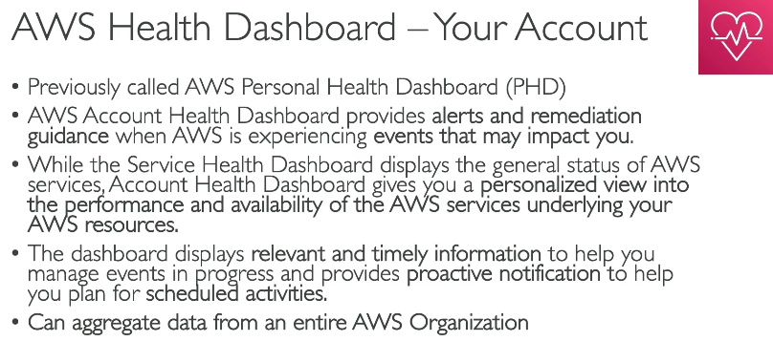
AWS Health Dashboard – Explained with Example
The AWS Health Dashboard gives personalized alerts and detailed visibility into the health of your AWS resources, services, and accounts. It helps track issues that may directly affect your AWS environment.

✅ Two Views in AWS Health Dashboard
- Service Health
  - General AWS service status across all regions (public view).
  - Useful for knowing if AWS itself is having outages (e.g., S3 down in us-east-1).
- Your Account Health
  - Shows issues specific to your account, such as:
    - EC2 instance issues
    - Scheduled RDS maintenance
    - Auto Scaling events
    - Networking disruptions

📘 Scenario-Based Understanding
🔹 Scenario:
You deployed a web app on EC2 in us-east-1. One day, your website is slow or not loading.
🔸 Steps to Check AWS Health Dashboard:
- Go to AWS Console
- Search for "Health Dashboard"
- Click on “Your Account Health”
- You might see a message:
  - 🔴 "Degraded performance in EC2 us-east-1"
  - Or a planned maintenance like:
    - "Instance restart scheduled for i-1234abcd at 3 AM UTC"
✅ Benefit: You immediately know why your app is affected and if it’s on AWS's side.

📊 Types of Events Shown
- Open Issues (ongoing)
- Scheduled Changes (like maintenance)
- Notifications (upcoming impacts)
- Recent Issues (closed/past)

🔔 Pro Tip: Automate Alerts
- Use Amazon EventBridge to trigger notifications or Lambda functions when a health event occurs.
  - E.g., Send Slack/SNS alert when RDS has a scheduled maintenance.

📦 Use Cases
- Monitor EC2 hardware failures
- Get alerts for Auto Scaling events
- Know when AWS outages affect your region or services
- Stay ahead of planned service disruptions

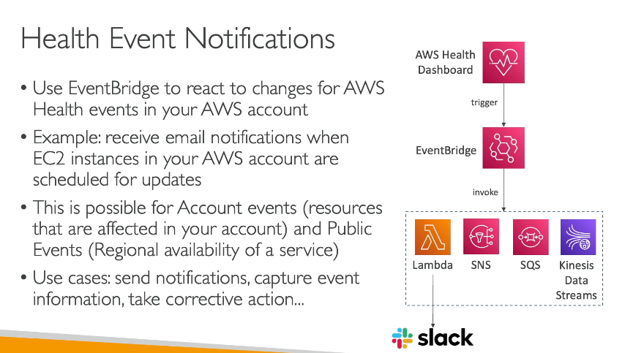
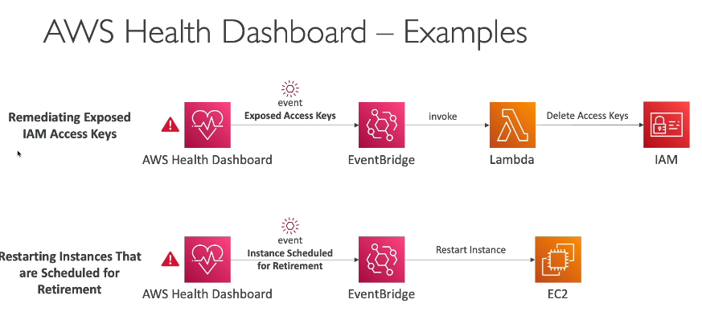
How Do Notifications Work?
By default, AWS Health events are visible in the Health Dashboard, but you can automate notifications using:
✅ Amazon EventBridge + SNS (or Lambda)
You can create a rule in EventBridge that listens for Health events and then triggers actions like:
- Sending an email via Amazon SNS
- Invoking a Lambda function to respond automatically

📌 Scenario: Be Alerted on EC2 Instance Hardware Degradation
🧩 You have an EC2 instance running a critical app. AWS detects that the underlying hardware is degrading.
🔄 What happens:
- AWS Health Dashboard creates an event:
  - AWS_EC2_Instance_Hardware_Degradation
- EventBridge rule captures this event.
- SNS topic sends you an email or SMS notification.
- You replace the instance or migrate workloads before failure.

AWS Organizations – Overview
AWS Organizations is a service that lets you centrally manage multiple AWS accounts in one place. You can create accounts, group them, apply policies, and manage billing centrally.

📌 Why Use AWS Organizations?
Benefit |  |  |  |  |  |  |  | Description
Central Billing |  |  |  |  |  |  |  | One bill for all accounts
Account Isolation |  |  |  |  |  |  |  | Separate workloads or teams in different accounts
Service Control Policies (SCPs) |  |  |  |  |  |  |  | Restrict what accounts can or can't do
Automation |  |  |  |  |  |  |  | Easily create and manage accounts programmatically

🧩 Scenario: A Company with Multiple Teams
Let’s say you're a DevOps engineer at a company that has:
- A development team
- A testing team
- A production environment
✅ Benefits in This Case:
- Dev team can experiment without affecting prod.
- Testing team is isolated from live data.
- Production account has strict security policies.
- All bills are consolidated and visible under one master account.

🛠️ Key Components
1. Root
Top-level container that holds everything.
2. Organizational Units (OUs)
Group accounts logically (e.g., by environment or team).
3. Accounts
Each account can have its own resources and users.
4. Service Control Policies (SCPs)
Policies to restrict what actions accounts can perform (e.g., deny access to S3 in dev).

💡 Example: Apply a Policy to Dev OU
You want to block IAM user creation in all Dev accounts.
- You create an SCP that denies "iam:CreateUser"
- Attach the policy to the Dev OU
- All accounts in Dev OU will now be restricted from creating IAM users.

🔐 Security & Control
- You can enforce compliance using SCPs.
- AWS SSO (Single Sign-On) integrates easily with Organizations for centralized access control.

📊 Billing View
All child accounts roll up into the management account so you can:
- Track individual account usage
- Set budgets and alerts
- Use Cost Explorer and consolidated billing
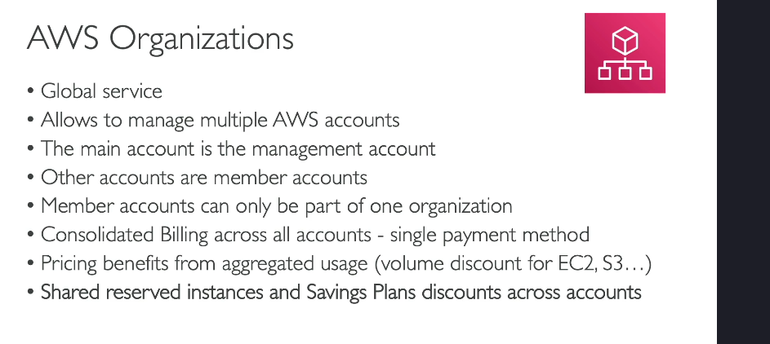

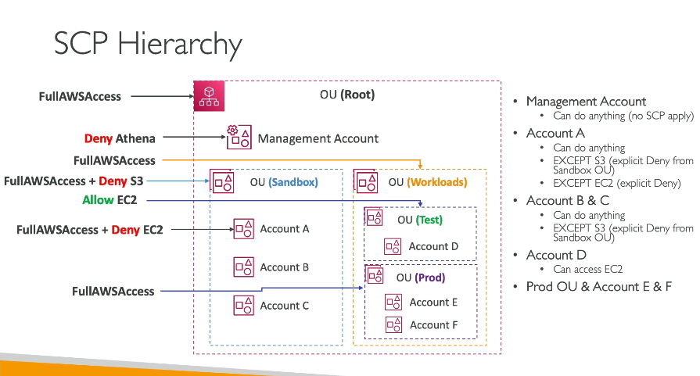

What is AWS Control Tower?
AWS Control Tower is a service that helps you set up, govern, and manage a secure, multi-account AWS environment automatically based on AWS best practices. It builds on top of AWS Organizations.
Think of it as a ready-made governance setup that gives you a "landing zone" with guardrails, pre-configured accounts, and blueprints for new environments.

✅ Why Use Control Tower?
Benefit | Description
✨ Easy Multi-Account Setup | Sets up a structured, secure AWS environment
🛡️ Built-in Guardrails | Enforces security and compliance policies
🔄 Automated Account Provisioning | Creates new accounts using Account Factory
📊 Centralized Monitoring | With CloudTrail, AWS Config, etc.
💰 Integrated Billing | Uses AWS Organizations for cost control

💼 Scenario: Your Company Expands Fast
Let’s say you're in charge of the cloud setup for a growing startup.
You want:
- A development account
- A testing account
- A production account
- And you want these accounts pre-secured, with audit logs, guardrails, and networking already in place
Instead of setting this up manually for each account (a lot of work 😩), you use AWS Control Tower.

🧩 How Control Tower Helps in This Scenario
When you launch AWS Control Tower, it does this automatically:
- ✅ Creates an AWS Organization
- ✅ Sets up core accounts:
  - Management Account: Root/parent
  - Log Archive Account: Stores all logs (CloudTrail, Config, etc.)
  - Audit Account: Security auditing tools, read-only access
- ✅ Applies Guardrails (pre-built SCPs and Config rules):
  - Prevent public S3 buckets
  - Require MFA
  - Detect untagged resources, etc.
- ✅ Creates Organizational Units (OUs):
  - E.g., Sandbox, Workload, Core
- ✅ Provides "Account Factory":
  - A self-service portal to spin up new AWS accounts with pre-configurations

🎯 Example: You Create a New Dev Account
You go to the Account Factory → choose:
- Account Name: dev-account
- OU: Workload
- Select some pre-set options (like region, VPC setup, etc.)
Click Provision → AWS Control Tower automatically:
- Creates the new account
- Adds it to the right OU
- Applies logging, security, and guardrails
- Sets up networking
You're ready to build without worrying about baseline security and structure!

🔐 Guardrails Explained
There are two types:
- Mandatory: Always enforced (e.g., no changes to Control Tower roles)
- Strongly Recommended: You choose to enable (e.g., restrict regions, block root access)
These are based on:
- SCPs (Service Control Policies) – Hard limits
- AWS Config Rules – Monitors resource compliance

📊 Visibility & Monitoring
Control Tower integrates with:
- AWS CloudTrail – Logs all API activity
- AWS Config – Tracks resource compliance
- AWS CloudWatch Dashboards – Visual insights
- SNS Notifications – For changes or violations

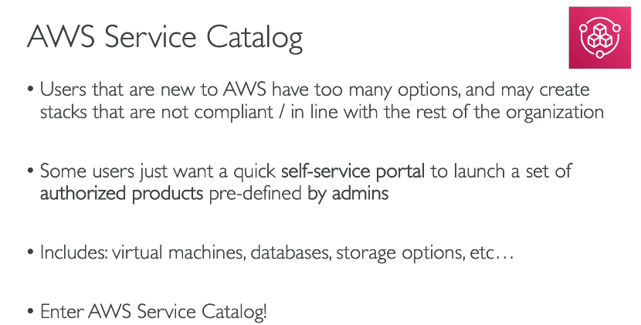
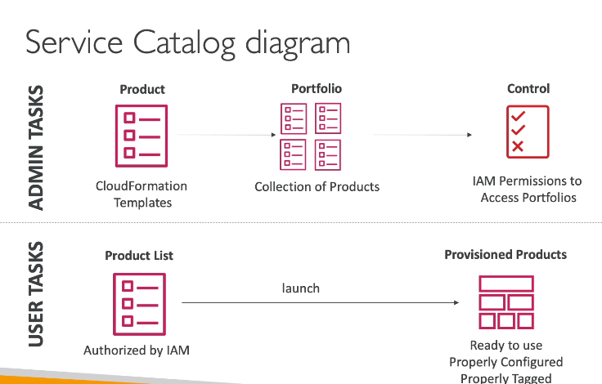

What is AWS Service Catalog?
AWS Service Catalog allows organizations to create, manage, and distribute approved IT services (like virtual machines, databases, apps) as catalogs to end users in a controlled and secure way.
Think of it like:
🔖 An internal "app store" of pre-approved AWS resources that your team can launch safely.

✅ Key Benefits
Feature | Description
🎛️ Self-Service | End users can launch resources without needing admin rights
🔐 Governance | Admins can enforce configurations, tagging, permissions
♻️ Reusability | Reuse CloudFormation templates as repeatable products
🧾 Auditing | Track who deployed what and when

🧪 Scenario: Dev Team Launching VMs
Imagine you're a cloud admin at a company. You want your developers to be able to launch EC2 instances for testing, but:
- ✅ Only certain AMIs should be used
- ✅ Tags should always be applied for cost tracking
- ✅ Certain instance types should be restricted
- ✅ The setup must include a specific security group
Instead of giving devs full access, you:
- Create a CloudFormation template with all these requirements
- Upload it to Service Catalog as a "Product"
- Add the product to a "Portfolio" (a group of products)
- Share the portfolio with your dev team
Now, devs can log into AWS, go to Service Catalog, and launch the product with just a few clicks — no need to worry about misconfigurations!

🛠️ Components of Service Catalog
Component | Description
🎁 Product | An AWS resource (like EC2, S3, RDS) defined by a CloudFormation template
📂 Portfolio | A collection of related products (e.g., DevOps tools, Web App stacks)
👤 Users/Groups | IAM roles or users who are allowed to launch the products
🔄 Versions | Different versions of the same product (e.g., v1.0, v2.0)
🔐 Constraints | Rules to restrict certain actions (e.g., allowed instance types, tag enforcement)

🧭 Step-by-Step Example
Goal: Let Dev Team launch a pre-approved EC2 instance setup.
- ✅ Create a CloudFormation template that:
  - Uses Amazon Linux 2
  - Specifies t3.micro only
  - Includes tagging
- ✅ Go to Service Catalog → Create Product
- ✅ Upload the template, give version name (e.g., v1.0)
- ✅ Create a Portfolio: “Dev Tools”
- ✅ Add your Product to the Portfolio
- ✅ Grant access to IAM group DevTeam
- ✅ Set constraints (e.g., prevent use of other instance types)
Now when devs log in, they see a “Dev Tools” section under Service Catalog, select the EC2 product, and launch it safely — no admin needed!

🧠 Summary
Feature | Description
🔖 Catalog | A safe "menu" of AWS resources for internal teams
🏗️ Reusable Templates | CloudFormation-backed products for consistent deployment
🚦 Controlled Access | Only specific users/groups can launch approved setups
🔧 Configurable | Define constraints, defaults, versions, and permissions
📈 Auditable | Track usage and ensure compliance

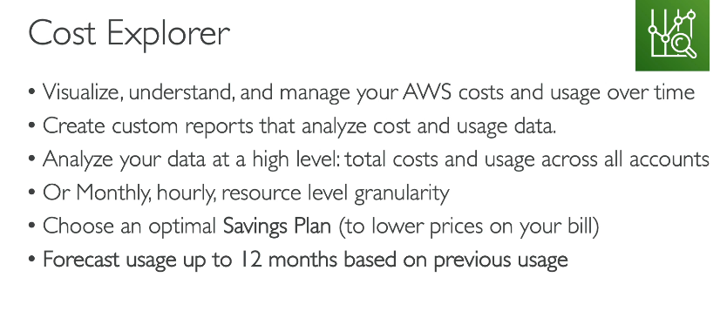
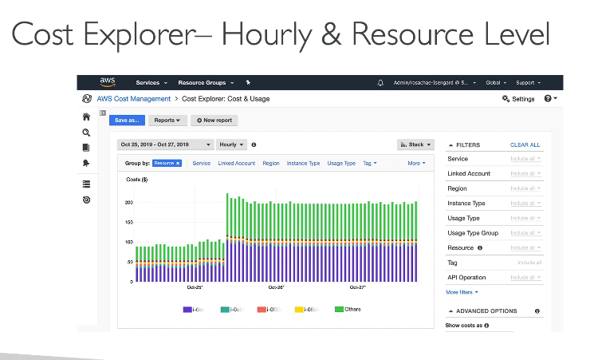
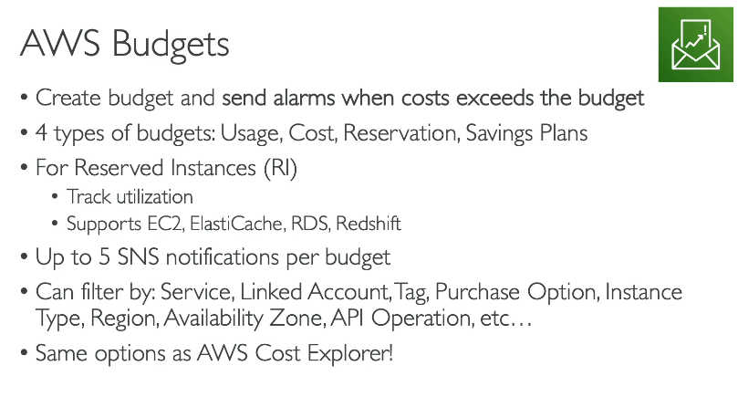

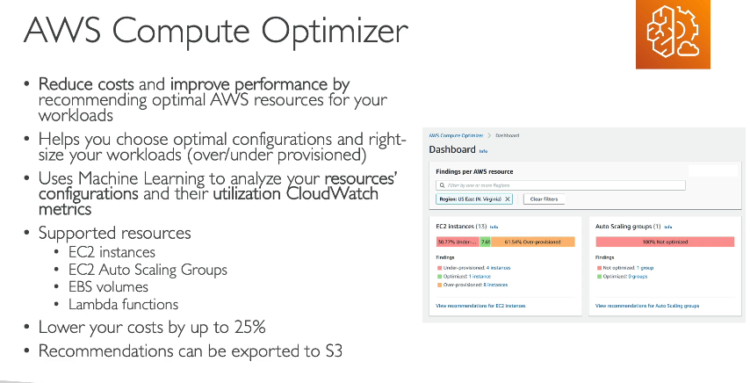

"AWS Service Catalog - TagOptions Library" is correct because the TagOptions Library in AWS Service Catalog allows administrators to standardize tagging by defining a set of key-value pairs that users must choose from when provisioning resources. This ensures consistency and compliance with organizational tagging standards.

AWS Organization - Tag Policies" is correct because Tag Policies enable you to enforce and standardize tag usage across all accounts within an AWS Organization, ensuring consistency and governance. This aligns with the learning objective of understanding how to manage and control resources effectively in a multi-account environment.

To prevent Reserved Instance (RI) discounts from being shared across linked accounts in an AWS Organization, you must:
🔒 Disable Reserved Instance discount sharing in the Billing Preferences of the account that owns the Reserved Instances.
This ensures:
- 💰 RI pricing benefits apply only to the specific owning account.
- 👥 No other linked accounts in the organization receive cost savings from those RIs.
- 🎯 Helps achieve accurate cost allocation, especially for chargeback models or when specific teams or departments fund their own resources.

